**Analysis:**

**Introduction:**

My idea is to make a top-down shooter roguelike with the working title Gilbert the Godslayer, as the player is playing as a regular human man, Gilbert, who gets sent to slay Greek Gods. The player will spawn into an ancient Greek battlefield with the ability to move, throw hammers, and dash, launching them forward and making them temporarily invincible, allowing them to dodge enemy attacks and reposition as to not feel overwhelmed. These basic features will make for a strong foundation for the game which I can then build off of.

After some time, enemies will spawn around them, and try to attack. Some will fire projectiles, some will just run at them. Different enemies have different speeds, movement patterns, health, damage etc, as well as a variety of visual designs based around Greek mythology, adding variety to combat to engage the player.

Defeating an enemy will give exp, and getting enough exp will provide a choice between 3 stat-buff type power up. These may be health buff, damage buff, speed buff etc. They’ll have different rarities, with rarer ones being better, giving players a reason to keep on collecting these power-ups - wanting to collect these rare, powerful effects.

There will also be power-up drops spawning randomly throughout the map, and when you defeat a stronger enemy. These ones randomly change the effect of your hammer. It may be that, whenever you shoot, there’s a 10% chance that the hammer sets on fire, or a 20% chance it freezes the enemy. However, once again, there are rarities. Rarer ones will do things like spawn a T-rex which attacks enemies, or turn an enemy into a zombie which fights for you, or cause a massive explosion. I think the rarer, unique power ups, such as the T-rex, will be what sets this game apart from its competitors - people will want to find these wacky, interesting power-ups

After a certain amount of time, a boss spawns, which has a lot of health. If the player overcomes the challenge and defeats it, they win, and are able to watch a short cutscene bringing the game to a satisfying conclusion. If at any point they lose, they have the option to start another run immediately, hopefully helping them overcome any annoyance that comes from losing, and giving an addictive feel to the game.

The game takes inspiration from many games which I have been playing recently, and really enjoy, including Hades, the Binding of Isaac, and especially Enter the Gungeon. These games are a part of the roguelike genre, one defined as a game where you lose everything if you die, giving it a run-like structure. These games can be immensely fun and intense, and also allow people short on time to play for 20 minutes before putting down. The roguelike genre has become very popular in recent years, but I think it is missing a game which fully emphasises the randomness which makes the genre appealing, and combines it with chaos to become a very fun game.

The game engine I’m currently thinking of using is Unity, which uses C#, due to its wide range of tools for 2D game design, and intuitive UI, which will be good for me as I haven’t done any game design before.

**Research:**

The first game that I took inspiration from was Enter the Gungeon, due to it having similar gameplay. I think it’s a fair comparison due to both being top-down roguelikes with a focus on ranged combat.

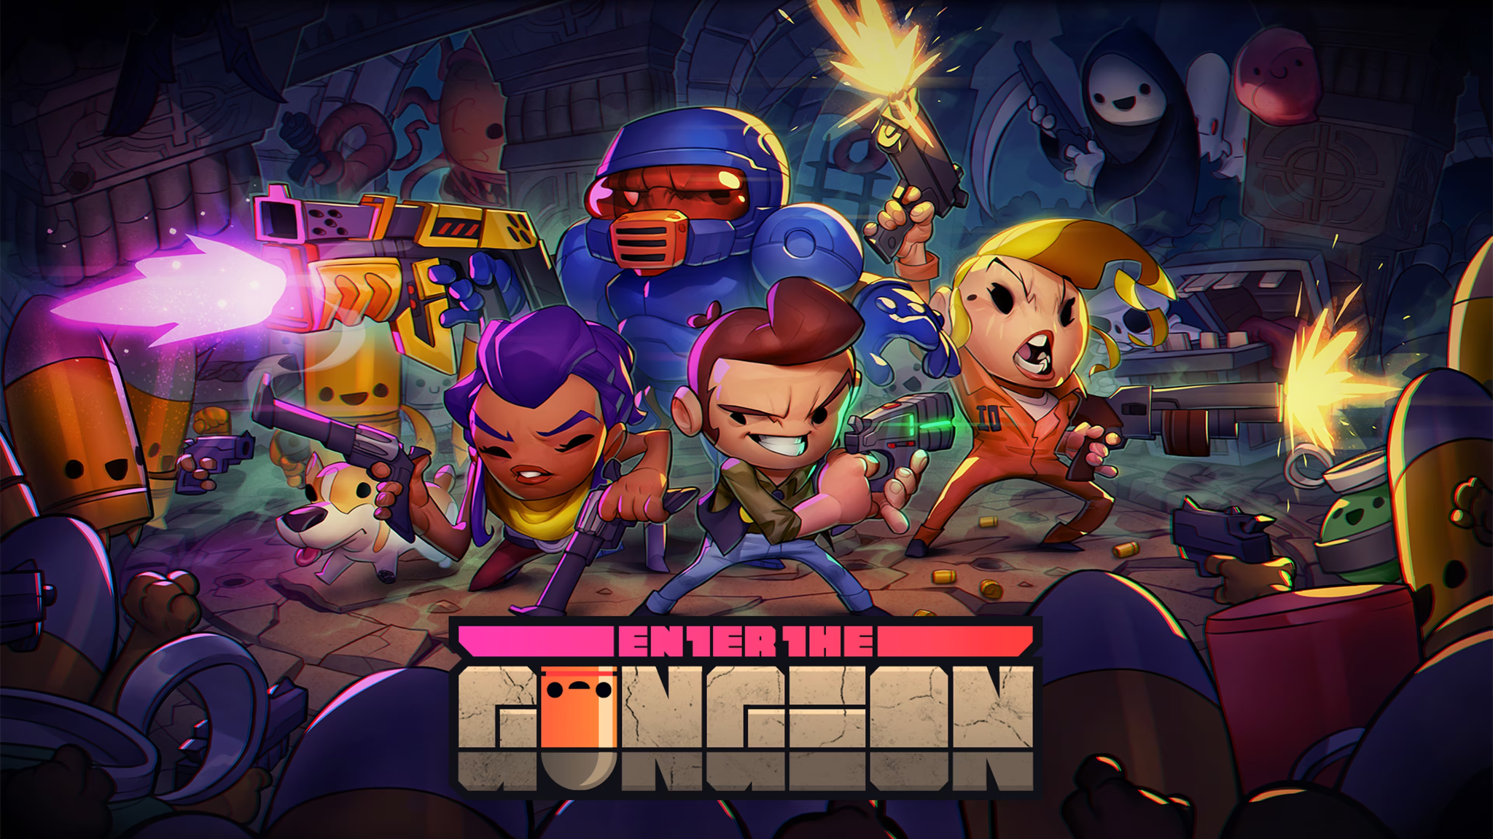

1. Official Artwork, taken from Playstation Store <https://www.playstation.com/en-gb/games/enter-the-gungeon/>

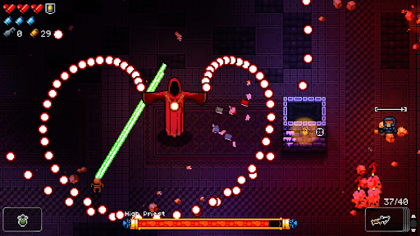

1. Screenshot of a boss battle, taken from the Play Critically review <https://playcritically.com/2021/05/09/enter-the-gungeon-review/>

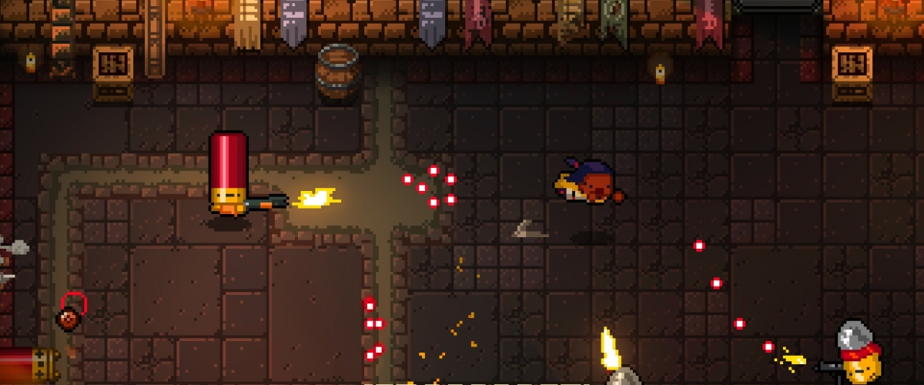

1. Screenshot of the game, from the Shacknews review <https://www.shacknews.com/article/94140/enter-the-gungeon-review-high-caliber>

|  |  |
| --- | --- |
| Things I would like to take inspiration from for my project | Things I would like to avoid for my project |
| The cartoony pixel-art visuals are perfect for my game, both being easier for me to design, and allowing me to aim the game towards a younger audience as opposed to adults, due to it being full of appealing character designs, and avoiding anything graphic.  The general movement system would work very well for my game. Both games feature walking, shooting, and a dash which grants invincibility.  The walking of Enter the Gungeon allows your movements to be precise, perfect for dodging the many bullets being fired at you, and the aiming isn’t tied to the direction you’re moving, allowing you to avoid enemies whilst you shoot back. My game would feature more close range enemies, so similar principles would be useful, in my case for running away instead of dodging bullets.  The dodge roll would be a great inspiration for my dash. It launches you forward, allowing you to become invincible for a second to avoid attacks, adding an element of skill due to the precise timings needed. The dodge is also very satisfying and very well choreographed visually to the player, allowing them to know when they’re invincible, which is important for avoiding the frustrations of being hit when you didn’t think you would be.  I also like that Enter the Gungeon doesn’t take itself too seriously, and doesn't have a theme with the items. It is full of jokes, be it weapon names being puns, or the comedically massive quantity of references to guns all over the game. Weapons range from guns to lasers to a mailbox to the letter ‘r’. This approach will be used in my power-ups, which should have this random nature, to hopefully make the player laugh. The game is marketed to a younger audience, so this would be a way to keep them engaged. | Run variety in Enter the Gungeon mostly comes from collecting different guns which shoot differently. I, however, think it’d be better to stick with the one weapon, which simply shoots one projectile when you click. I want my run variety to come from power-ups, which should hopefully get quite complex, however adding in different weapons may completely overcomplicate it, and overwhelm the player with all the different options. It may also limit the design of my power-ups, as I’d have to make sure they work for all guns, and if an idea I have is incompatible with a certain weapon type I wouldn’t be able to do it.  Enter the Gungeon also implements an ammo system, where you can only use a weapon a certain amount of times before having to reload, and if you use it too much, the weapon runs out of bullets and can’t be used further. I think it would be best to keep this out of my game, as the special effects on my weapons happen randomly. This would encourage you to shoot as many hammers as possible, to increase the chance that the effect occurs. An ammo system would discourage you from throwing out as many hammers as possible, and so you wouldn’t see these effects as often. It would also add a resource management element to the game, which can cause stress to the player, which is something I want to avoid when the game will already be fast paced and intense.  The levels are split up into rooms, which you are confined to until all enemies have been dealt with in that room. I’d rather have an open map, due to an increased number of enemies that would become overwhelming in a small space, turning the game frustrating. |

The next game that I looked at for inspiration was The Binding of Isaac. I wanted to see what I could take from this game specifically due to it being a top-down roguelike that contains lots of good things that I like about it that I want to take inspiration from, whilst having a lot of flaws that I would like to avoid.

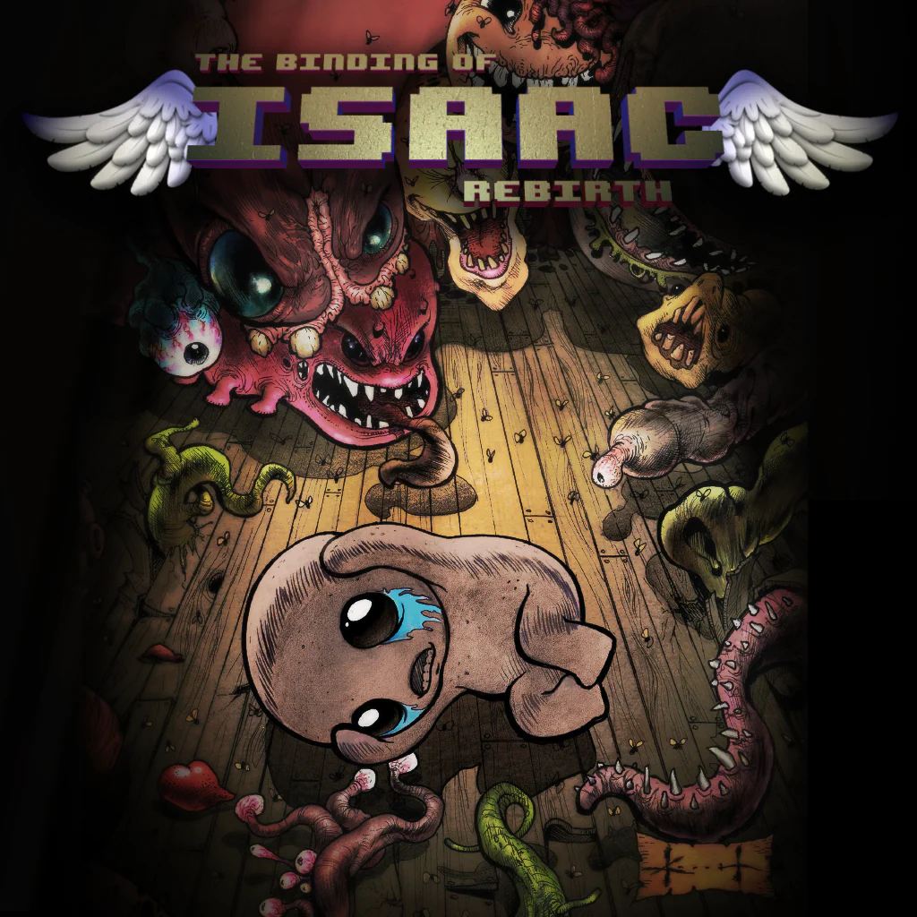

1. Official Artwork, taken from Playstation Store <https://www.playstation.com/en-gb/games/the-binding-of-isaac-rebirth/>

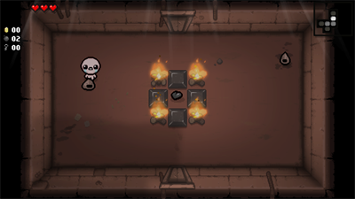

1. Screenshot of gameplay from LaunchBox Games Databox <https://gamesdb.launchbox-app.com/games/images/80151-the-binding-of-isaac-afterbirth>

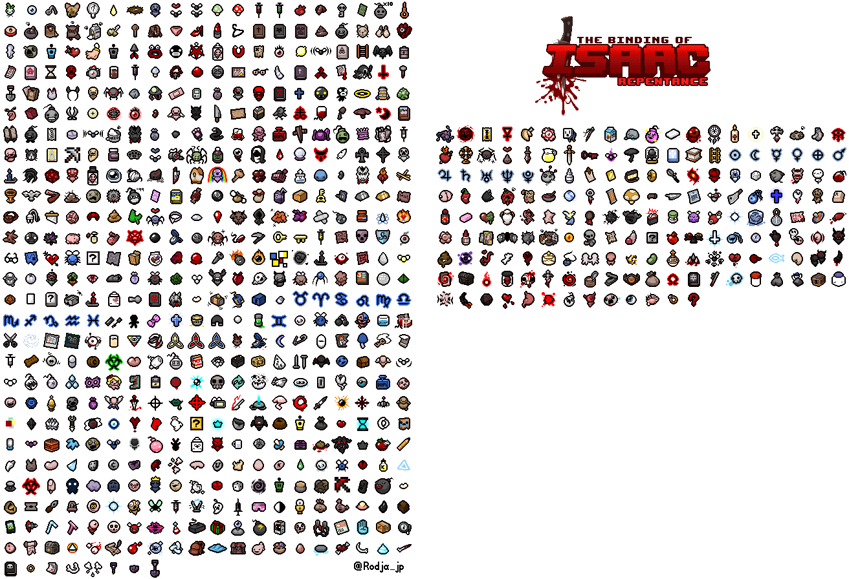

1. The sprite sheet for all items in the Binding of Isaac, which I got from The Spriters Resource <https://www.spriters-resource.com/pc_computer/bindingofisaacrebirth/sheet/188967/>

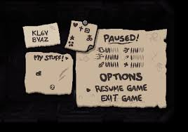

1. A pause menu found on Steam<https://steamcommunity.com/app/250900/discussions/0/133258092255867313/>

|  |  |
| --- | --- |
| Things I would like to take inspiration from for my project | Things I would like to avoid for my project |
| One of the biggest things I will take inspiration from is the wide range of items. There are 717 collectible items in The Binding of Isaac, all of which have unique effects. This ranges from simple changes like a damage buff, to completely changing how the game is played, such as the ‘Mom’s Knife’ item changing your projectile based attack into a melee one. This is the type of variety I want in the power-ups of my game - some being simple damage buffs, and some completely changing how you play. Whilst I doubt I’ll be able to reach the sheer number of items that Isaac has, it can still serve as an aspirational goal to even come close to the amount of variety it has.  Another thing I like about The Binding of Isaac is the projectile Isaac fires. At the start of the game, he shoots a single tear, doing a bit of damage. However, collecting items changes it massively into being far more interesting, which is the ethos I want in my item design, which will also have the main projectile be a single shot, in this case a hammer.  As seen in the pause menu, the UI is very simple, and thematic for the game, being designed to look like it was scribbled onto a few bits of parchment which Isaac carries around with him. It simply shows your stats, options, a resume button, exit button, and your items, all laid out clearly and simply. It can’t be easier to understand, which is something I’ll want if I’m appealing to teenagers, who may be adverse to too much reading. | The setting is completely inappropriate for my game. It is set under Isaac’s house, but is made to be as disgusting as possible, featuring blood, flesh, and excrement everywhere. While this adds some shock value for an older audience, if I’m aiming the game to under 18s, I definitely need to avoid this as there’s a good chance they wouldn’t be allowed to play my game with this setting.  Each room is very small and claustrophobic, which wouldn’t work in my game due to a high enemy count which would quietly cause it to get full and become impossible to dodge.  You can only shoot a projectile in the 4 cardinal directions. In my game, where there will be a lot of enemies all over the place, that’d make it very difficult to hit enemies, and force you to have to move strangely just to aim, making the game feel tedious.  It is also a very difficult game, and I don’t want my game to be too hard, as a teenage audience may get frustrated with the game and quit if they keep on losing.  Whilst there is a wide range of items you can collect, there is no in game explanation for what they do. For my game, the player might find this confusing, and I want to make sure they have enough information as they could need to avoid creating a frustrating experience. |

The final game I took inspiration from is Hades. It is yet again a top-down roguelike, similar to my game, but with massive gameplay differences, letting me know what I don’t want, but also giving me ideas for things not commonly found in other, more standard top-down shooters.

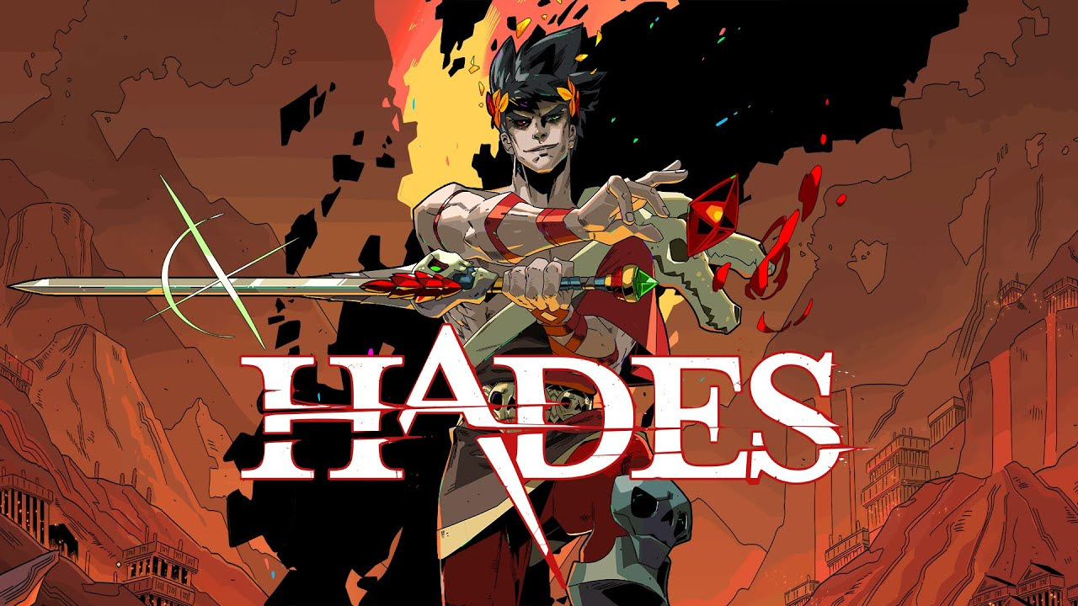

1. Official art, taken from Supergiant Games’ website<https://www.supergiantgames.com/blog/hades-faq/>

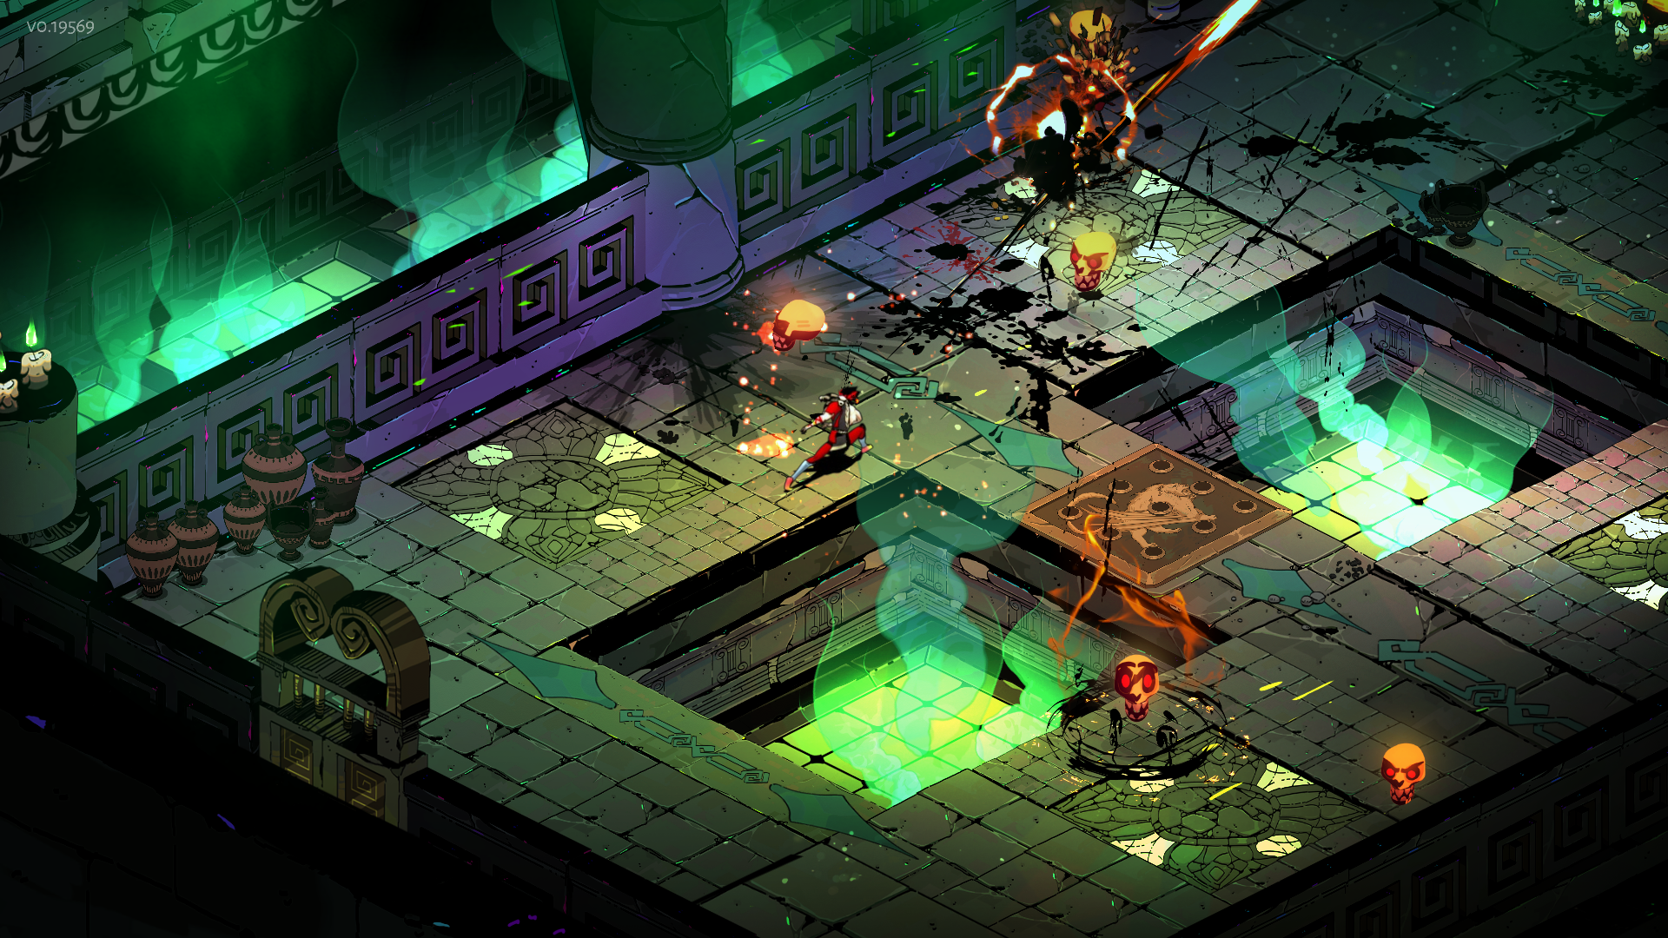

1. A screenshot of gameplay, taken from Supergiant Games’ website<https://www.supergiantgames.com/games/hades/>

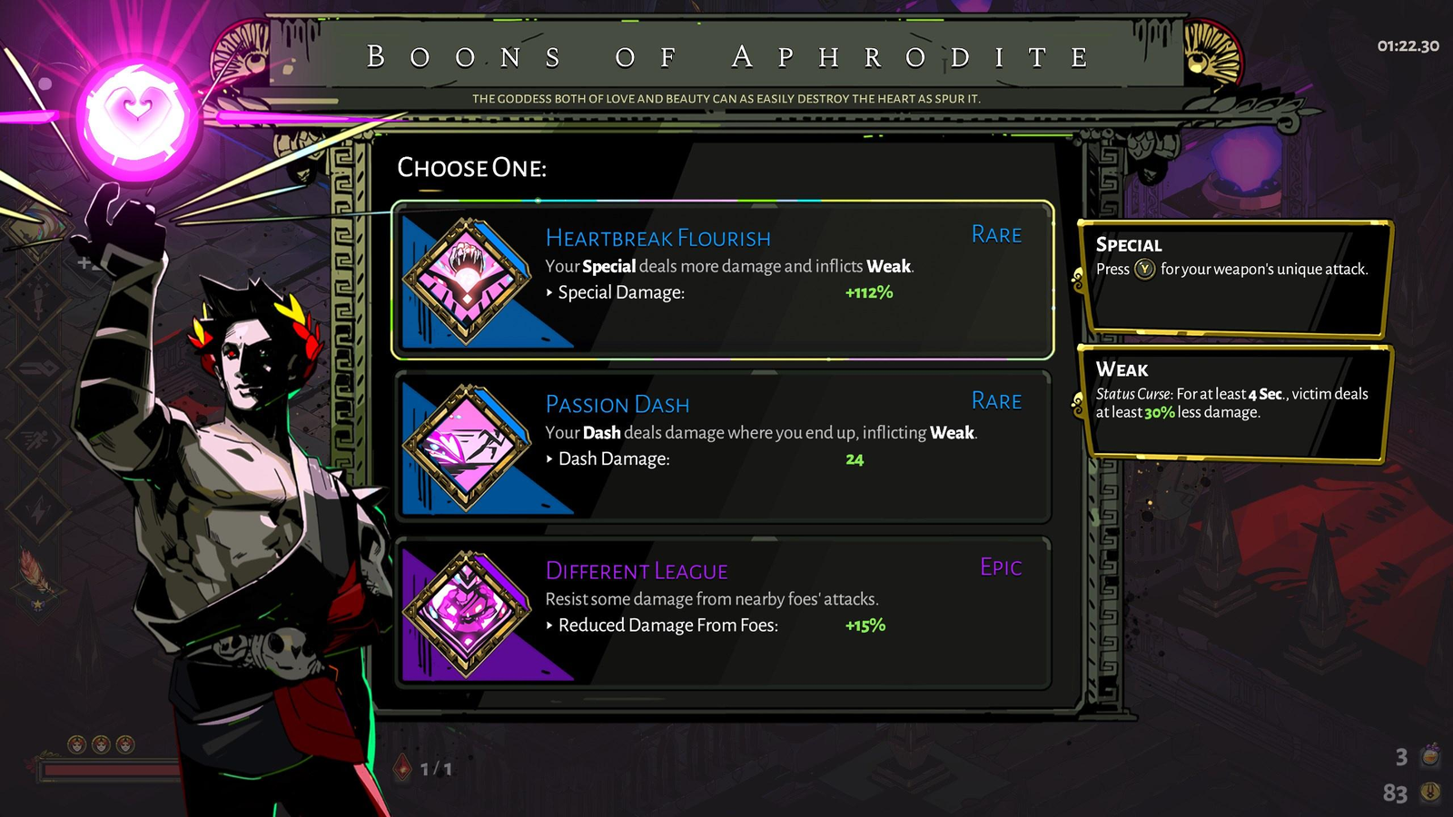

1. The boon (powerup) selection screen, taken from Rock Paper Shotgun <https://www.rockpapershotgun.com/hades-boons>

|  |  |
| --- | --- |
| Things I would like to take inspiration from for my project | Things I would like to avoid for my project |
| I’d love to use the layout of the boon selection screen for my power-up selection screen. It lays out 3 options very neatly and clearly, with a short simple explanation of everything you need to know. It also gives the rarity, which is important for my players to know if they’ve found something special, making sure they don’t miss out. Off to the side, it also gives an explanation of any effects that would be inflicted, which makes sure the main part doesn’t get crowded, but is giving you all the information you need.  It also has a similar setting - both being Greek mythology. Whilst this one is set in the Underworld, whereas mine would be above ground, the enemies and characters are all from Greek mythos, which I would also like to use. | The way the power-ups work are more restrictive than I want. In Hades, you can have one effect on your weapon, one on your dash etc, whereas I’d like to encourage you to stack as many power-ups as possible, as I think that can cause a chaos which would be appealing to a teenage audience.  Hades is also technically a rogue-lite rather than a rogue-like, meaning that, despite it still being run-based, resetting if you lose, there is permanent progression that carries on, in Hades case being currencies like Darkness, which you can spend to become more powerful, making the game easier. I want my game to be more like something you can hop on, do a run or two, and then get off without anything carrying over, as a lot of teenagers may not have the time to put into a long game with permanent progression because they are bogged down with studies. This is seen in their affinity for online games, which once again don’t really have permanent progression. |

Stakeholders:

My initial target audience for this game are casual gamers between the ages of 12-18. The game is designed to be fast-paced and intense, which would keep this audience engaged, despite a shorter attention span. Runs also shouldn’t take too long, allowing it to be played at any point when someone has a few minutes of free time. This works well for a 12-18 audience who are just casual gamers, and may not have too much free time due to increased amounts of homework and studying that they must do.

The game would be cartoony, and avoid anything graphic, allowing it to be advertised to a younger audience, however may be too intense and violent for anyone under 12. It would be difficult, as a player of this audience would want it to be challenging, otherwise they may get bored of it, however it wouldn’t be so hard that it becomes frustrating, or that a player wouldn’t consistently win once they get good, as a casual gamer may not want to spend ages trying and trying over again just for a single win. The Greek Mythology theme may also help attract this audience, as they have grown up reading Greek myths in school, and books like the Percy Jackson series by Rick Riordan.

Stakeholder Survey:

To see how the stakeholders react to my idea, I sent out a survey. It features these questions:

How much do you enjoy playing video games?

How much do you enjoy top-down shooter games?

What art style would work best for the game?

What atmosphere would be most appealing for this game?

How difficult would you want the game to be?

How long would you like a run to last?

If you could only have one, would you prefer a lot of enemy types, or a lot of power-up types?

Would the game be improved if it recorded your best score (most exp collected)?

Do you like the idea of a Greek Mythology Setting?

How close should the enemy designs stick to this setting?

How much do you like the sound of this game?

When I have a functional build of the game, do you want to test it and do another survey later?

* The first 2 are just to get an idea of who is taking the survey, and how much they enjoy gaming in general.
* It then gets to art-style. I hadn’t had my heart set on a specific art style yet, so I wanted to see what people said, and confirm my suspicions that a 12-18 audience would enjoy a not-realistic art direction.
* The general atmosphere was another thing I needed input on. Whilst I suspect under 12s want a brighter atmosphere, and adults would prefer a grittier one, I wasn’t sure what would appeal most to the 12-18 audience.
* Difficulty was something I thought it would be good to get input on, as it is very easy to make the game too easy or too hard, and I needed an idea of where to aim for.
* Run length was another thing I wanted input on. I knew I wanted them to be short, to fit in with a teenager’s tight schedule, however I didn’t know how short I wanted them to be, as ‘short’ can range from a quick 3 minute run to around 15 minutes.
* Because I am a single developer who probably won’t have too much time to work on this, I also wanted to know where’s best to focus the majority of time on after I get the basics of the game down. Should I focus on enemies or power-ups?
* I also had the idea of adding a high-score mechanic based on the amount of exp you collect. I wanted to see if that was something the stakeholders would care about and if it would improve the game, as if they seem excited about the idea, it could improve replayability.
* My original idea for the game was a Greek mythology setting, as I thought that could be something that would appeal to a teenage audience. I wanted to see if my hypothesis was correct so I added that as a question, too.
* If people enjoyed the setting, I also wanted to know how accurate the enemies should be to the setting. They may want every design to be fully true to the origins, or they may be okay with me taking liberties with the designs.
* Lastly, I wanted to see if the whole game appeals to my original target audience, or if I had made a mistake and should change it. This was arguably the most important question in the survey for me.

After some time, the results came in:

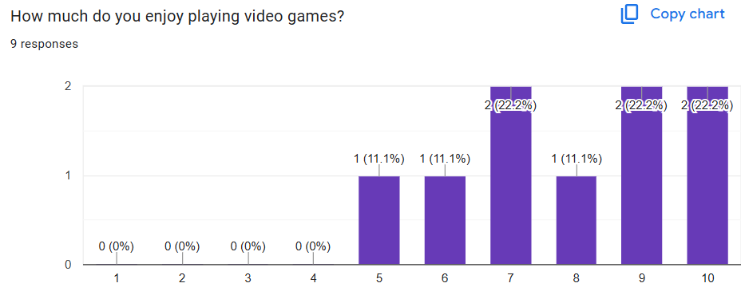

Question 1 shows that, as I expected, everyone who was in my target audience had a favourable opinion of video games, so the information I get from my survey should be valuable for creating a video game.

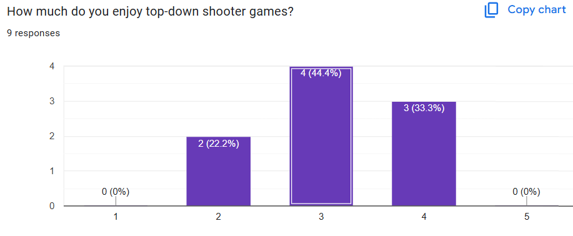

The results of the second question showed that none of the stakeholders I surveyed actively hated top-down shooters, however none of them loved them either, ranging from slightly negative to slightly positive. This would be useful for once I complete the survey on a beta release of my game, to see how they’d compare my game to others in the genre, as well as being able to fix the gripes they have with games in this genre.

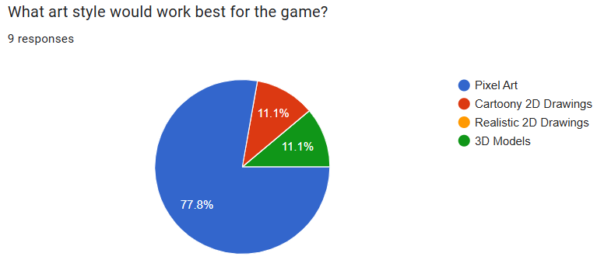

For the art style, the vast majority of people wanted pixel art.

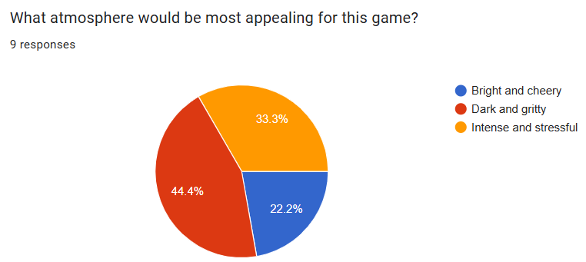

For the atmosphere of the game, most people wanted it to be dark and gritty, or intense and stressful. These make sense as the target audience will be in the transition of child to adult, so making games with a less childish atmosphere would come across as appealing. This suggests I could set it in a cave or dungeon, and have a lower light level to the game.

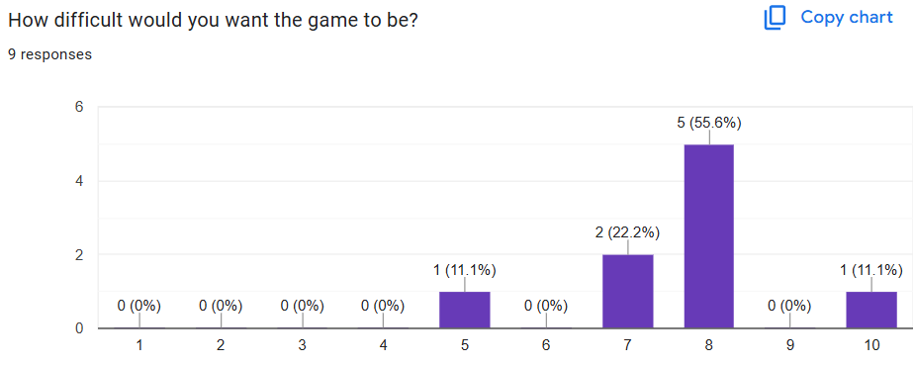

In terms of difficulty, most people wanted it to be reasonably challenging, with the majority putting it as an 8. This suggests I should put focus on balancing the game to make it fair, whilst it being quite difficult to get a broken game-destroying run.

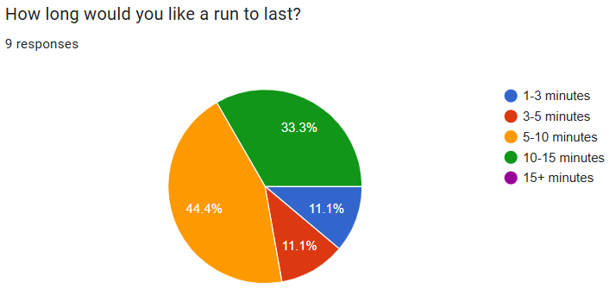

The poll for run length showed that most people wanted a run to last between 5 and 10 minutes, or between 10 and 15 minutes. The average of this poll can be calculated by (2+4+4(7.5)+3(12.5))/9, which comes out as 8.2 minutes. This means I should aim for a run to be around this time. As I want it to be that the boss spawns after a constant amount of time, I could have it spawn at 6 minutes, and take around 2 minutes to defeat, averaging 8 minutes per run.

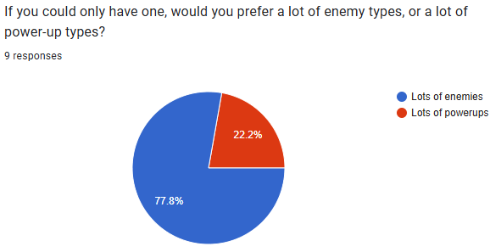

The vast majority of people wanted lots of enemies, suggesting I should create a small group of useful power-ups and focus more on creating interesting combat experiences with a diverse cast of enemies.

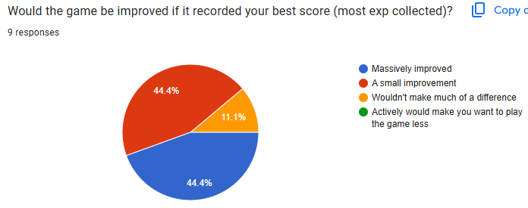

People seemed generally positive towards the idea of a high score system, however over half didn’t think it would be a massive improvement to the game. This suggests it is something I should add further down the line if I have time, but isn’t an essential feature.

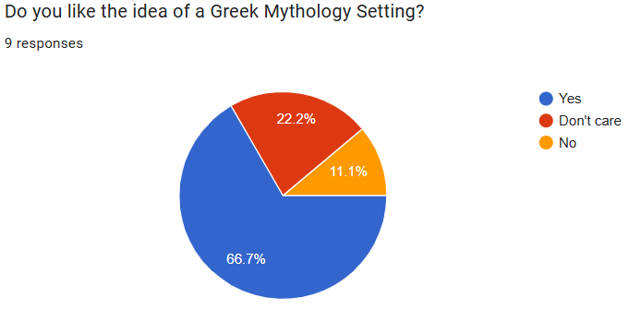

This confirmed my suspicions that my stakeholders would enjoy the Greek mythology setting, and it is the route I should go down.

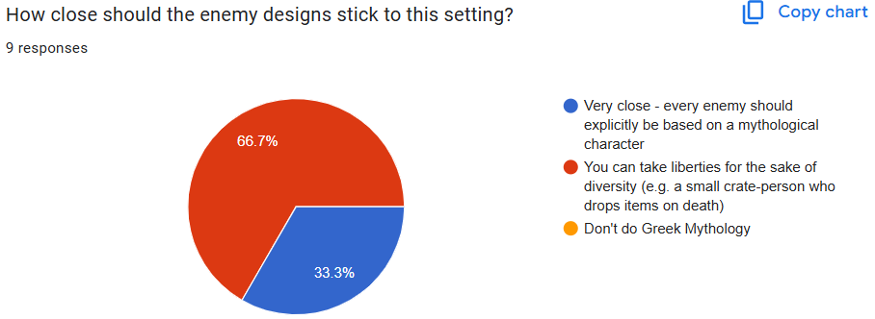

Whilst the Greek mythology setting was liked, the result of this poll shows it doesn’t have to be completely accurate, and I can take liberties for the sake of game design.

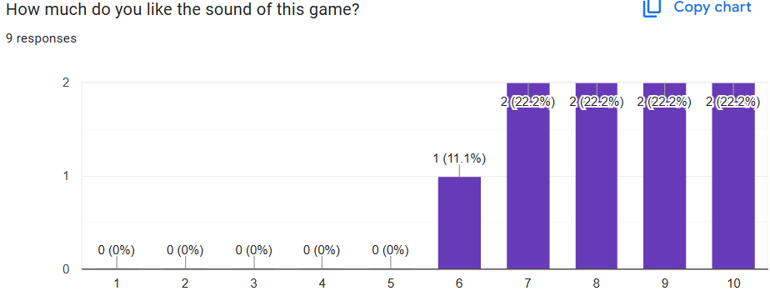

The final question was to see how much they enjoyed the sound of the game, with the average rating being 8.2. This shows that I have done a good job with the concept, and aiming it towards a 12-18 audience I’m designing it for.

User Requirements:

Importance key:  
Mandatory = Literally no game without it

Important = The game has failed if I don’t have this

Desirable = Makes the game significantly better, but doesn’t ruin the game if it’s excluded

Nice to Have = Benefits the game, but is at a low priority and will only be added if I have time

|  |  |  |  |
| --- | --- | --- | --- |
| **Feature** | **Description** | **Justification** | **Importance** |
| Start Menu | When opening the game, the start menu is what greets you. It will contain the title of the game, Start Button, and High Score (if these are implemented). | Every game I researched has a start menu for when you open the game. It makes sure you aren’t immediately thrown into a game when you aren’t ready. This is important, as it would frustrate the player if they left their computer for a minute to get water, for example, to find the game has been running, and they’ve been getting attacked for the past minute. It also gives a home to the player’s High Score, if that gets implemented. | Desirable |
| High Score System | When the player defeats enemies, they collect exp. This is used both for getting power-ups, but could also be used as a score to measure how well they’re doing. The score would be displayed on the HUD whilst playing, and their highest score would be recorded by writing it to a file, to be displayed on the Start Menu. | A high-score system would increase replayability, as players try to get as high of a score as they can. It may also encourage them to take risks, and defeat harder enemies to improve their score further, creating more intense moments, which the stakeholders seem to want, with 33% voting for an intense and stressful atmosphere. However, when asked about this system specifically, over half of the stakeholders said it would only bring a small improvement, or no improvement at all, and it doesn’t affect the main gameplay loop much, so it will only be added if I have time. | Nice to Have |
| Start Button | If the Start Menu is implemented, it will feature a Start Button which puts you into the game. | If there is a start menu, there will have to be a way to transition between menu and gameplay, and I think a clickable button is the way to do it, as it will be obvious enough to only be clicked on intentionally, making sure all games start only when the player wants it to. I also considered having the game automatically start after a certain amount of time, however that takes away some player freedom, as they can’t start early, if they want to jump into a game immediately, or they can’t wait a long time, possibly leaving the computer, as a game will start automatically, and they may not be there when it does. | Essential |
| Movement System | In the game, your character needs to move. Moving will use the WASD keys to move the character in each cardinal direction. | A movement system is essential for gameplay, or else the player will be a sitting duck for enemies, which may be frustrating. Teenagers appreciate freedom, and no movement would remove some of that. I decided to use WASD to move, as it is quite common in the industry and the games I researched, and would be most comfortable to play when combined with a mouse. | Essential |
| Shooting System | When you click the left mouse button in a game, a Hammer projectile will be fired from your character in the direction of your mouse position. This will be the attack used to defeat enemies. Hammers will travel in a straight line for a small distance and then despawn. | The player will need a way to shoot enemies, or else the game isn’t in the player’s control and they will feel weak, causing frustrations. I decided to use the mouse to aim, as that will allow the player to be more accurate with their shots, avoiding annoying misses that aren’t because of skill. I considered using the arrow keys to aim, like in the Binding of Isaac, however, during my research, I found it to be quite difficult to aim, and became quite tedious. | Essential |
| Dash | When you click the right mouse button, your character will be launched in the direction that they’re moving. This will also give them a small amount of invincibility from enemy attacks. There will be a period after you dash where you cannot dash again. | This mechanic was found in 2 of the games I researched, and made them immensely more enjoyable. It gives a sense of control to the player, and allows them to avoid enemies' attacks with precise timing, making the game require some more skill, which would help increase the difficulty to a level around what my stakeholders wanted. I deemed it to be important and not essential as the game will still work without it, however I think it is a mechanic that should be high priority for the sake of making the game enjoyable. | Important |
| Enemies Spawn | Various enemies will appear at random intervals in random places on the map, however never on the player’s screen. | This is mandatory as without there being enemies, there is no game. I think making it random will help increase replayability, and make each run feel different, as you never know where the enemies will come from, and it also increases difficulty, which the stakeholders want, as you can’t predict where they’ll come from. The enemies shouldn’t spawn on the player’s screen both to increase immersion into the game, as it may be quite jarring for an enemy to spawn randomly, but also to decrease frustrations with a powerful enemy spawning right on top of you. | Essential |
| Enemies Attack | Enemies will move towards a position where they can do damage to you. This may be running at you and dealing damage when they touch you, or keeping their distance and firing a projectile that damages you if it touches you. To implement this, the player will need a ‘Health’ variable which will decrease if hit by a successful attack. | To make the enemies threatening, they need to do damage. This will be the main source of difficulty that the players must overcome. The melee ones increase intensity, which the stakeholders want, as they’d constantly chase you down, and the projectile ones increase diversity in enemy types, making the game more interesting, but also make it more difficult, as you have to focus on dodging their attacks as well as the horde of melee enemies. | Essential |
| Enemies can Be Defeated | If an enemy is hit by a Hammer, it will take damage. If it takes enough damage (the exact number depending on the type of enemy), it will be defeated, and disappear, and you will gain exp. | To make sure the game is possible, you must be able to defeat the enemies. Dropping exp gives the player a reason to go after enemies, creating these intense situations which the stakeholders wanted. | Essential |
| 10 Enemy Types | There should be at least 10 types of enemies, which will all have different designs. They may also have different movement speeds, health, damage, and attack differently. If they are more powerful (having significantly more health or damage), they will spawn less often. There will be 4 ranged enemies, 5 melee enemies, and the 1 boss enemy. | To make sure the game doesn’t get boring quickly, there must be a variety of types of enemies that work differently. The different visual designs will interest the teenage audience, and the gameplay differences between them will force them to change how they play, increasing the difficulty. Different enemy types were in all 3 games I researched, meaning it is clearly very important. | Essential |
| More Enemies | If there is time, I will add more enemy types | Whilst I feel like 10 enemies is a minimum for the game, my stakeholders clearly wanted a very large amount, with 78% voting for more enemies over more power-ups. This means that it is important for me to add as many as I can, which would increase replayability, as people want to see all the enemies that they can. All the games I researched had more that 10 enemy types, with the Binding of Isaac having over 300. Whilst I can’t get to those numbers, I can try to get as many as I can, within reason. | Important |
| Gaining a Power-Up After Enough EXP is Collected | After defeating an enemy, you gain exp. If the amount of exp you have exceeds a certain number, you get a character-boosting powerup. The amount of exp you need to get another power-up increases each time you collect the power-up. | This gives you an incentive to defeat enemies and collect exp. The player will want to get more powerful, so they will have to fight enemies, and get into these dangerous situations, increasing intensity, which the stakeholders seemed to want. | Important |
| Power-Up Gems Spawn Across the Map | At random points throughout the game, a Power-Up Gem will spawn. If you break it open, by throwing hammers at it, you gain a power-up that applies effects to your hammer. Power-up Gems cannot spawn on the player’s screen. The player will be notified when and where the Power-Up Gem is. | This gives you an incentive to explore, rather than staying in one safe location. The player will want to get more powerful, and see the hammer power ups which are more interesting, forcing them to leave their comfort zone. | Essential |
| 10 Power-Ups | There must be 10 types of power-ups you can get. They come in 2 types: hammer-changing and character-boosting, and there will be 5 of each. Hammer-Changing power-ups are probability based, and will do things when you throw a hammer. Character-boosting power-ups will strengthen your character. The power-ups will be:  Damage Up  Speed Up  Health Up  Dash deals Damage  Passive Healing  Flaming Hammer  Electric Hammer  Explosive Hammer  Hypnotising Hammer  T-Rex Spawning Hammer | The power-ups are what make you stronger. They incentivise exploration for power-up gems, and defeating enemies for exp. Without them, it would also be too difficult to defeat the boss, who should be especially powerful, and probably push the game to be harder than what the stakeholders want. The power-ups I chose are supposed to provide a variety of unique effects, with some being more interesting and rarer, giving the player incentive to replay until they come across the rarer ones. | Essential |
| More Power-Ups | If there is time, I will add more power-ups | Whilst 10 power-ups provides a good range of options, I do think there should be more, to increase run diversity, and give the player more reason to replay. However, it isn’t a priority, as when I surveyed the stakeholders on whether they preferred more enemies or more power-ups, far more chose more enemies, with power-ups only having 22% of the vote. | Desired |
| Screen for Selecting Power-Ups | When you get a power-up, it should pause the game, and bring you to a different screen, where there is a choice of 3 power-ups. You click on the one you want, and it gets applied to your character. | I think it would be good to have a separate screen for the player to decide what power-up they want. It gives them a way to choose what they want, and create their own power-up compositions, giving them freedom which is something a teen will appreciate. I also considered just randomly giving them a power-up, which would keep them in the battle as opposed to taking a break on a different screen, however that takes away some player control, which I don’t think is a good idea. This power-up screen will be heavily influenced from Hades, as that perfectly displays all important information. | Desired |
| HUD | Whilst playing the game, at the top of your screen, it shows your health, score, and how close you are to your next power-up. After you dash, it will also show a bar which decreases until you can dash again. There will also be the timer until the boss spawns. | A good HUD should give the player all information they should know to allow them to understand what’s happening. For example, if they have low health, they’ll see that and understand that, to win, they must be careful. I thought other information that would be useful would include how close they are to the next power-up, which may encourage them to take risks to get enough exp, a bar to show when they can dash, allowing them to more precisely dodge attacks, and the timer, so they know how long they have to get more powerful until the boss spawns. I also considered putting this information in the pause menu, which would give them more time to think about how they should play, however I think it could become tedious to switch between menus, and all the games I researched have this info on their HUD. | Desired |
| Boss Spawns after Timer | After around 6 minutes of gameplay, Zeus spawns. He is an especially powerful enemy who can throw lightning bolts at you, spawn enemies, and use a sword. He has a lot more health than most other enemies, and deals a lot of damage. However, if you defeat him, you win the game. | There needs to be a boss, both as a win condition, and to give the player a reason to get more powerful, as they need to beat this impossibly strong enemy. I thought it would be best to spawn after a timer, as it gives the player a time limit to rank up, otherwise they would be able to farm exp, and get too powerful with no time pressure. I am currently thinking 6 minutes is a good time for the timer, as my stakeholders wanted the game to last, on average, 8 minutes, so if there is a 6 minute timer, and it takes 2 minutes to beat the boss, it should reach that number in most games, however this is subject to change depending on how hard the boss is. | Essential |
| Victory Screen | After you defeat Zeus, this is the screen it brings you to. It has a congratulatory message, and the option to restart. | I think a screen after you win would be a more satisfying reward to the player than just going back to the main menu, or immediately restarting the game, as it gives them time to look back at their victory. It also gives them a place to restart, rather than having to get back to the main menu. However, the game will function fine without the victory screen, so it is only important. | Important |
| Loss Screen | If at any point you run out of health, this is the screen it brings you to. It has a message that taunts the player, and the option to restart. | I think a screen after you lose would be good for replayability, as they can immediately jump into another run. If I add a light-hearted, taunting message, it may also make the player feel challenged to restart and try to win this time, especially for the competitive audience of a teenager. It also gives them a place to restart, rather than having to get back to the main menu. However, the game will function fine without the victory screen, so it is only important. | Important |
| Pause Menu | If you click the Tab button at any point, the game temporarily freezes, and it brings you to a different screen. On this screen, there’s the option to unpause, and see the probability pie-chart if that’s implemented. | Useful for if the player needs to take a break whilst playing. Games should last around 8 minutes, which is enough time for something to come up that you have to do which is more important than gaming. If that happens, you don’t want to just lose your run, so it would be better to implement a menu that stops the game where you are, and you can carry on later. | Nice-to-Have |
| Pie-Chart Displaying Probabilities for Power-Up Activation | Either in the pause menu (if I am able to make it), or on the HUD, I may have a pie chart to show the probabilities that each hammer power up triggers. | With a multitude of probability based abilities all affecting the same attack, it could get quite confusing for the player. This would help the player understand the chances that their attacks trigger an ability without having to do complex maths. I’d prefer to have it located in a pause menu, as that would allow the player to read over the information and strategies without having to multitask. However, if it is well designed enough, it may be able to be placed on the HUD and still get all its information across. However, this information is neither mandatory for the game to work, or important enough to be of a high priority, so I’ve only deemed it ‘nice-to-have’. | Nice-to-Have |
| Pixel-Art Art Style | The game will be designed with a pixel-art art style | When given a choice between 4 different art styles, 78% of the surveyed stakeholders voted for pixel art. However, it is only visual, and would be quite time consuming to design whilst coding in the different features, so has only been deemed important. | Important |
| Animations | When moving, there will be simple animations for both you and the enemy, where the character models stretch and squash, to simulate movement. Hammers will spin when thrown. | Animations both help improve the look of the game, as they make it feel more alive and attention-grabbing, keeping the teenage audience engaged, but also help tell the player what’s going on: If the hammer is spinning, it is flying through the air. The way I want to animate everything keeps it simple, meaning I don’t have to create a new image for every frame of every animation. | Nice-to-Have |
| Victory Cutscene | After you win, there will be a simple animated cutscene showing you defeating Zeus, and returning to your world, victorious. | Currently, the game has no ending and no story. Adding a cutscene at the end of the game, I think, would make for a satisfying reward for beating the game, and gives a sense that there may be a deeper story, which may intrigue the player. Whilst children will be satisfied with games that don’t really have a story, older audiences, like my stakeholders, will want at least some part of a story, so I should at least give them something. However, this is very unnecessary for the game to function, so it is possibly the lowest priority thing on my list. | Nice-to-Have |
| Dungeon-like Setting | The atmosphere will be dark, with rocks, pillars and bones everywhere. The screen will fade to black around the edges. | When surveying my stakeholders on the atmosphere of my game, the most votes were given to dark and gritty. A dungeon would fit this, and be able to fit into the Greek mythology theme which the stakeholders seemed to like the idea of. It also allows me to darken the edges of the screen, shortening the field of vision of the player, allowing enemies to sneak up on them creating the intense situation the stakeholders wanted. However, it is only visual, so isn’t essential for the game to function. | Important |
| Sound | Sound effects will play when you hit enemies with hammers, defeat enemies, collect a power-up, and when the boss spawns. | Having sound effects would be a great aesthetic addition that will also better translate to the player what is happening, as there is audible feedback to every action. However, this will not change how the player plays the game at all, so is only really important for making the game better presented, as opposed to playing better. | Nice-to-Have |
| Volume Controls | In the home and pause screen, there will be a way to control all the volume if sound gets implemented. There will be a speaker symbol which has bars by the side where you increase the amount selected to change the volume. | If sound effects get implemented, different people will be used to different sounds, so giving them a way to choose their preferred volume will help them enjoy the game more. | Nice-to-Have |
| Colour Blind Mode | This will be an accessibility feature that increases the contrast and saturation of all colours so people with colour blindness can more easily see what’s going on instead of having different objects blend into each other. | This feature will widen the range of players who can play my game, as without this colour blind people may find my game confusing or even impossible to play. However, it is only nice-to-have, as the vast majority of players won’t need this. | Nice-to-Have |

Limitations:

|  |  |
| --- | --- |
| **Limitation:** | **Justification:** |
| Time Constraints | Due to the game benefitting from having as many enemies and power-ups as I can get, this game can scale near infinitely in size. The only limitation to how big it can get is the amount of time I have to implement all my ideas for power-ups and enemies, because I need to focus time on making the rest of the game too, with things like menu design, pixel art, and animations all also taking a lot of time. Once there is a good selection of power-ups and enemies, expanding other aspects of the game like the menu design will take priority because these aspects are important to help the game feel polished, benefitting the user experience more than simply adding more power-ups. |
| Lack of Experience | I have never made a game before, and have very limited experience in both C# and Unity. This means that I don’t yet have the ability to code a lot of complex ideas that require vast knowledge of the language, and may result in the final code being less optimised, harming the performance of the final product. Although I can eventually learn how to do these, it is once again time constraints preventing me from getting past the limitation of my lack of experience. |
| Animations | If I get to implement animations, they will be quite simple, mostly being based around manipulating the sprite rather than combining multiple sprites to simulate movement, which will decrease the realism of the game and make enemies’ attacks less readable, possibly catching the player off guard and causing frustration. This is because I, once again, don’t have the time to create many sprites, nor the artistic ability to make it look good without having to go through many iterations. |
| Language | The game will only be in English, as this is the only language I know well enough to add to the game. However, this will isolate non-English speakers from being able to fully understand my game, and may cause them confusion. However, all the surveyed stakeholders spoke English fluently, so solving this isn’t a high priority. The basic gameplay should also be simple enough to allow non-english speakers to still understand what to do, allowing them to still get some enjoyment out of my game. |
| Simplistic Mechanics | In the game, the player only really has 3 things they can do - move, dash and attack. This means the game will be quite simple, removing some complexity which I would want. From the games I researched, Hades had 3 different attacks as opposed to my 1, and Enter the Gungeon has 2 different item types you can make use of. Both of these add complexity and decision making which my game will lack. This means, to make the game as difficult as the stakeholders want it to be, I will instead need to make the enemies harder to defeat, as opposed to the mechanics being harder to learn, which may cause frustration. |

Hardware and Software Requirements:

The player will need a mid-range computer with a solid CPU and any graphics card, as the game shouldn’t be so power-intensive that it needs a very good CPU, but there will be too many enemies and moving parts happening at once to run on a weak CPU, and graphically it shouldn’t be intensive at all due to it being rendered in 2D with only simple graphics. They will need a mouse and a keyboard, as those are the controls I have chosen for the game, and a monitor to see the game. The user will need Windows 10 or later, as that matches the operating system version I am testing the game with, however the game may be able to be played on older versions, depending on how resource intensive it is.

For development, I will be using Unity (the game development program I will be using to make my game), therefore I need a computer which can run Unity. From the Unity website, I can see this means I will need to have at least 8GB of RAM in my computer, and for it to run on either Windows 10 or 11, if running Unity 6.1. (“Manual: System requirements for Unity 6.1”). Of course, software-wise, I will also need to download Unity, which I am using as it is good for beginner game makers due to its intuitive AI and premade attributes. I will also need Visual Studio, an IDE used for coding in C#, the language Unity uses.

What Makes This a Computable Task:

Whilst making this project, I will be using many computational methods:

* Decomposition will be used to break up all the different features in the game into simpler, more manageable parts. For example, when making the enemies, I’d break the problems down into designing their movement, attack pattern, stats, taking damage, spawning criteria etc. This turns a large, overwhelming task into a bunch of smaller tasks which are easy to think about and create the solution for.
* Solving the problem computationally also makes it easier to make changes after testing. If I find a balance issue, I just have to alter a variable, and retest until it feels fair, however if this was a physical board game, for example, it would be incredibly time-consuming and expensive to make iterative changes like this.
* Once I’ve used decomposition, I can use problem recognition to determine what type of problem it is, and if I notice two problems have a similar solution, I can reuse code in multiple places throughout the program if I solve it computationally. For example, the code to decide what way the enemy moves will be similar to the code that decides what way the hammer flies. If I solve one of these issues, I can reuse the majority of the code, making a few minor alterations, to solve the other, saving a lot of time and effort which can be used to develop more features.
* Concurrent processing will be needed, as many things will be happening at once. For example, in just one frame, you might move, enemies will chase you, you might spawn a projectile, and a damage calculation will take place. All these will happen at once, and only a computer can deal with them all simultaneously.
* Due to all the power-up triggers being based on probability, the program requires a way to generate random numbers. Computers can simulate pseudo-random numbers, which will work perfectly, and be far more efficient and feel more random than anything a human can do.
* There will have to be a lot of precise calculations done in fast succession, as the direction enemies move and hammers are thrown will be calculated using trigonometry. A computer will do this incredibly quickly, and be correct, so nothing unexpected will ever happen.
* Abstraction will also be used to simplify the game and make it fun. In real life, throwing a hammer would not make it travel in a straight line, as it would be affected by gravity. However, for the sake of letting your throws be constantly accurate, I’m removing the unnecessary detail of gravity, and allowing the hammers to fly straight.

**Design:**

**Structure Diagram:**

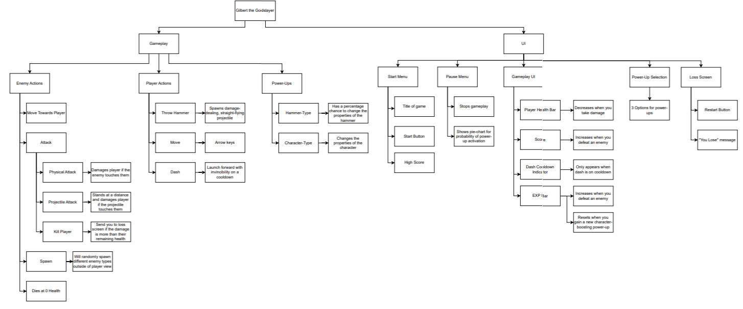

The first thing I designed was the structure diagram. It consisted of taking all the different features I planned for the game and organising them into a far more readable and well structured format. I did this to speed up future development as it will be far easier to see what I need to do in this format than in a table.

**GUI Designs:**

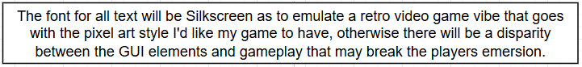

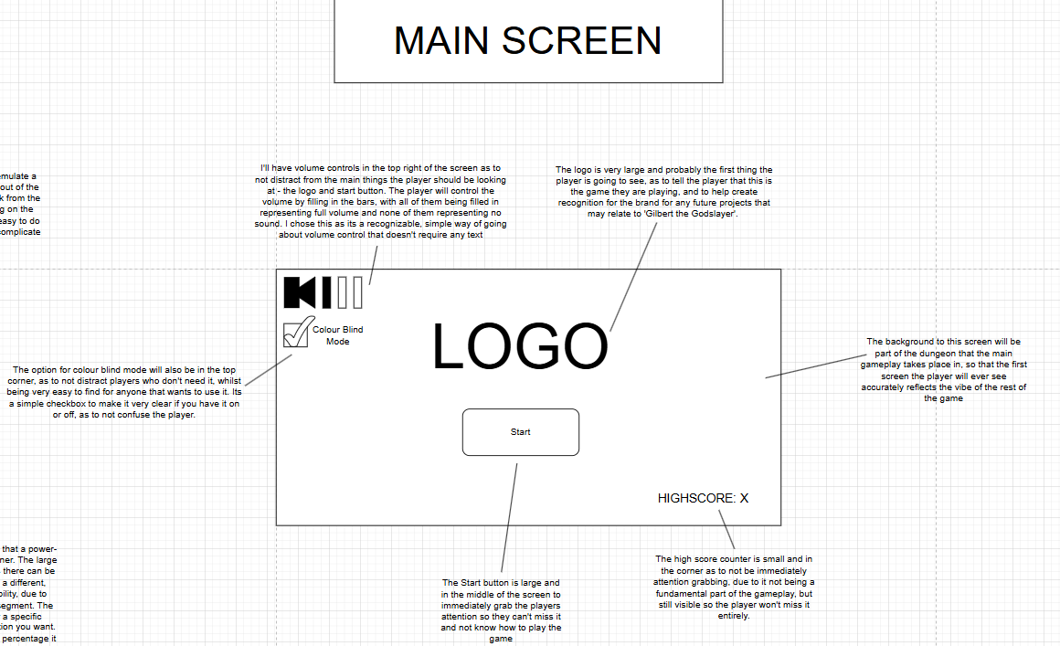

I first designed the main menu. This will be the menu that the player will be greeted by when they open the game, and contains the ‘Start’ button. I wanted this screen to focus on making it very clear to the player how they start playing so they can get into a game without any confusion.

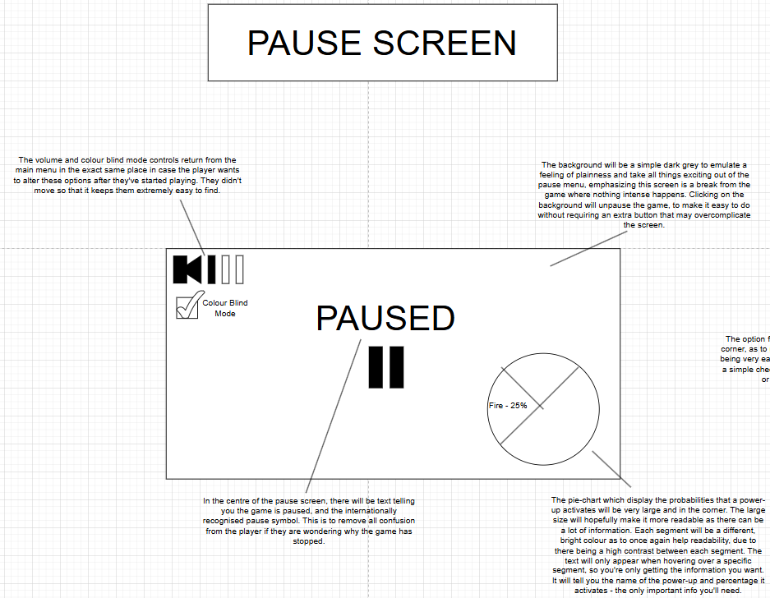

Next I designed the pause screen, a screen that is accessed by pressing escape, and is supposed to give the user a break from the gameplay if they ever need to stop for a few moments. I wanted to give this screen a purpose beyond simply stopping the game, so this is where I put some useful accessibility options, as well as the pie-chart which provides useful information on power-ups, as these are features that may have to be changed/checked during gameplay.

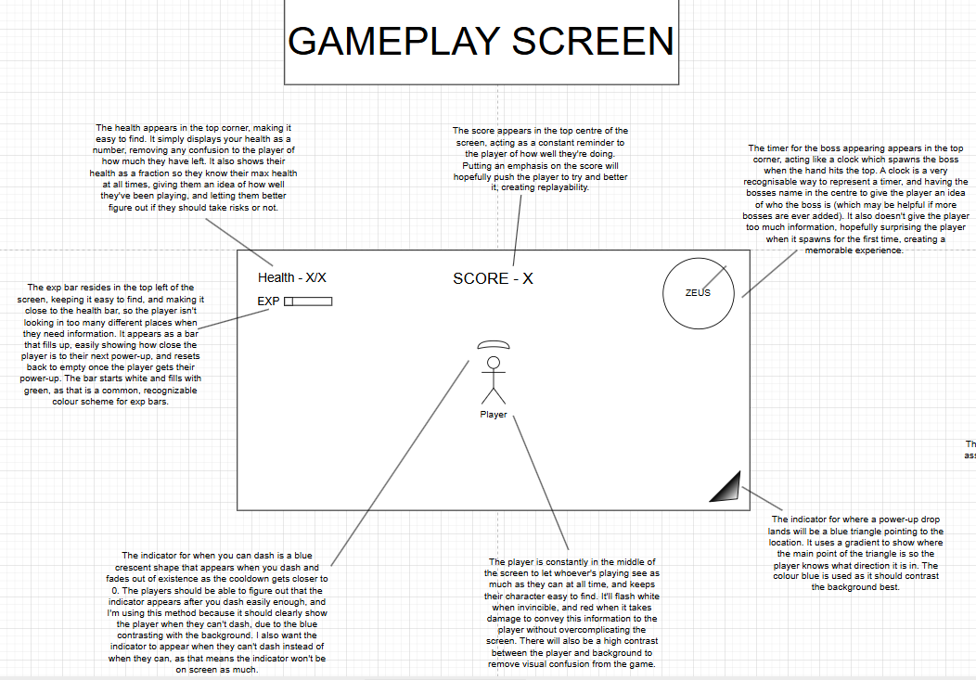

After that I designed the gameplay screen, which is the screen where the actual game is played. I wanted this screen to have as much empty space as possible, because it is important that the player can see what is going on without being distracted by non-gameplay elements, so that they can fully understand what is going on in the game.

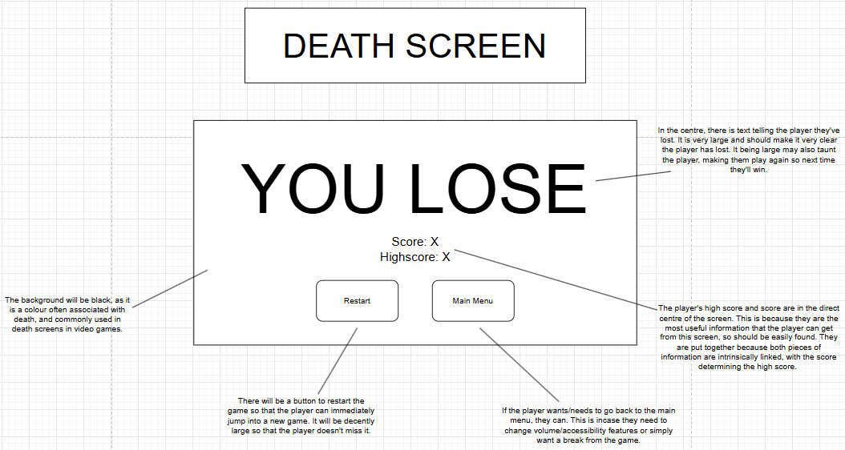

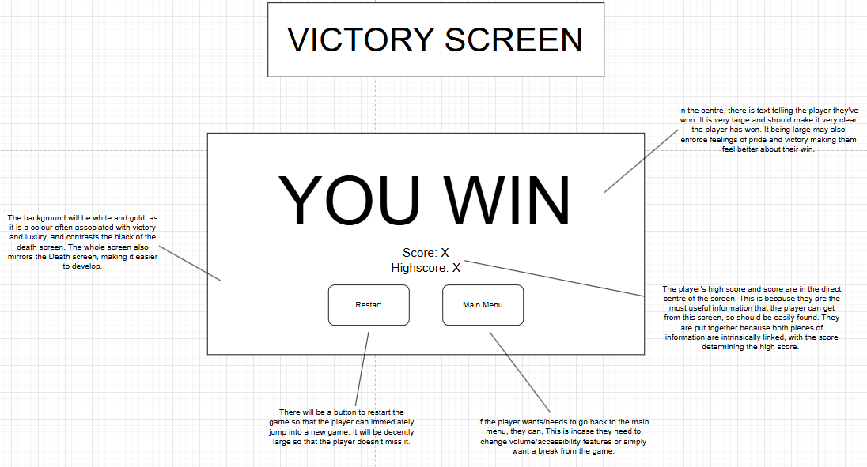

Lastly, I designed the Win and Loss screens, which would pop up after you defeat the final boss, or die, respectively. I want these screens to be simple, so that the player can easily read the relevant information and then immediately jump into another game.

**Development Plan:**

Next, I created an approximate development plan that broke my project down into stages, as well as giving a rough time-frame. This is to give me guidance for what I should be coding when, and it should make sure I don’t forget to add anything in.

Stage 1 - The Basics

This stage contains the most fundamental features that will be necessary for having a functional game and needed for testing all other features.

Contains:

Movement System

Shooting System

Time-Frame - Approximately 2 Lessons

Stage 2 - Enemies

This stage is based around having functional enemies that can move and attack.

Contains:

Basic Enemy parent class

Making enemies move

Making enemies attack

Making enemies spawn

Making enemies defeatable

Gaining exp from enemies

Dash

Time-Frame - Approximately 3 lessons

Stage 3 - Power-Ups

This stage focuses on creating the power-up system

Contains:

Creating Power-Up basics

Creating some power-ups

Time-Frame - Approximately 2 lessons

Stage 4 - Aesthetics 1

This stage focuses on some of the more important non-gameplay features

Contains:  
Start Screen

Death Screen

More enemy sprites

Health Bar

Exp bar

Time Frame - 2 Lesson

Stage 5 - More Enemies and Power-Ups 1

This stage focuses on adding in more enemies and power-ups, hopefully enough to fill out the amount stated in the user requirements

Contains:

The Boss

More enemies

More power-ups

Time frame - 3 Lessons

Stage 6 - Aesthetics 2

More, less useful things to make the game look better

Contains:  
Animations

Less important sprites  
Boss timer

Time-Frame - 2 Lesson

Stage 7 - Extras

This stage focuses on adding features deemed Nice-to-Have  
  
Contains:

High Score System

Pause Menu

Pie-Chart

Victory Cutscene

Sound

Time-Frame - 5 Lessons

Stage 8 - More Enemies and Power-Ups 2

The final ‘stage’ will be me using any extra time to add in as many enemies and power-ups as I can come up with.

Explanation:

I want the first stage to be the basics as that is the groundwork that all further features will be based off of. It will be impossible to test the enemies or power-ups without being able to attack, for example. Being able to move and shoot are the two most fundamental features that need to be implemented immediately for me to make the rest of the game.

I think it's then going to be most important to develop the features based around the enemies because having enemies is the next most important feature that allows me to test the later features, such as power-ups. It also means I have an actual game, with the gameplay loop consisting of running around defeating enemies.

The next stage will be based around power-ups. This third stage completes the core gameplay loop, and all later stages will be based more around polishing the game.

After that, I want to focus on adding more aesthetic features which are useful for conveying information to the player, and allowing me to see useful information during testing like how much health the player character has. I also expect the features in this stage to be pretty simple to develop meaning I’m not spending too much time early on on aesthetic features.

Next, I want to add more enemies and power-ups. In the user requirements, I said I wanted 10 of each, so this stage would be focused on getting to this number. This stage is important for making the game more fun and less repetitive, and is the last stage with gameplay features I deemed important.

Following that, I’d like to add more visual changes to polish the game more. This is one of the last stages because it really isn’t affecting gameplay at all, but it's still nice to have to make the game look better.

The last real stage is adding all the gameplay features deemed Nice-to-Have. These are features that, in my stakeholder survey, people didn’t think were super important to have, but still would improve my game, so if I have any time left over, I should add in.

Lastly, with any left over time, I’ll create more enemies and power-ups. I think this is the best way to add more content to the game, as it increases run diversity, making the game more replayable.

Every stage will be tested after completing it.

Video Citation

**Stage 1:**

Data Dictionary:

|  |  |  |  |  |
| --- | --- | --- | --- | --- |
| **Class** | **Attribute** | **Data Type** | **Method** | **Description** |
| **Player** | Health | Integer |  | Decreases when damaged, ends game when =0 |
|  | Speed | Float |  | The speed the player moves at |
|  |  |  | Movement() | Method for moving |
|  |  |  | Shooting() | Calculate angle between mouse and character and spawns hammer |
| **Hammer** | Direction | Float |  | The angle the hammer moves at |
|  | Speed | Float |  | The speed the hammer moves at |
|  | DespawnTimer | Integer |  | Decreases every second, destroys hammer when =0 |
|  | Damage | Integer |  | How much damage the hammer does |
|  |  |  | Flying(float direction) | Method for hammer travelling |

Movement():

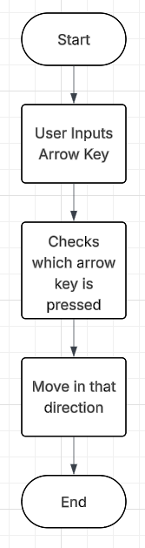

Movement will be simple. In the Update() method (which is called every frame) the program will simply check if a key has been pressed, and if it has, it will move the character in that direction. For something as basic as movement, I shouldn’t overcomplicate it, and I put it in the Update() function as that is the built in way to repeat code every frame, saving me time, and the code needs to be repeated every frame so that the instant that the key is pressed, the player should move to make the game feel fluid and responsive.

Shooting():

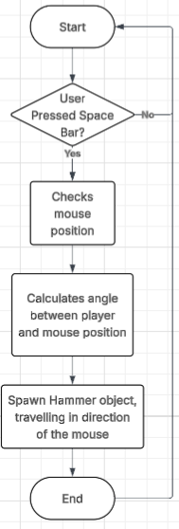

This also takes place in the Update() method for similar reasons as Movement(). The calculation for the angle

Flying() - Pseudocode:

WHILE DespawnTimer!=0

PositionX = PositionX + speed*cos(direction)  
 PositionY = PositionY + speed*cos(direction)

DespawnTimer = DespawnTimer - 1

IF DespawnTimer = 0

destroy().this

ENDIF

ENDWHILE

Every hammer spawned will immediately travel in the direction passed into the flying() method non-stop. I decided to add a despawn timer so that, if the player never hits anything with the hammer, the hammer will eventually still be removed from the world, saving resources and helping the game run better.

Test Table:

|  |  |  |
| --- | --- | --- |
| **Test** | **Expected Result** | **Actual Result** |
| Press the ‘D’ key | Player’s X coordinate increases | Player’s X coordinate increases |
| Presses ‘A’ key | Player’s X coordinate decreases | Player’s X coordinate decreases |
| Press the ‘W’ key | Player’s Y coordinate increases | Player’s Y coordinate increases |
| Press the ‘S’ key | Player’s Y coordinate decreases | Player’s Y coordinate decreases |
| Move the mouse | Crosshair sprite follows the cursor | Crosshair sprite follows the cursor |
| Left click the mouse | Spawns a hammer from the player that travels in the direction of the mouse | Spawns a hammer from the player that travels in the direction of the mouse |

**Stage 1 Development:**

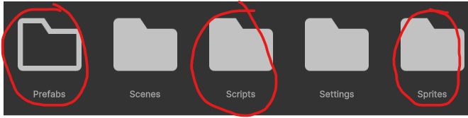

Before I did any coding, I wanted to add some organisational folders to my project, which I did by adding a folder for all Scripts, Sprites, and Prefabs. This should make navigating my project far easier, and will reduce the amount of time I spend looking for specific items due to them all being stored in one place.

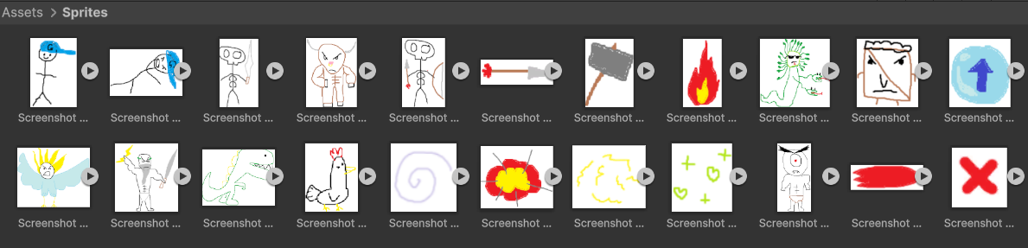

I then created a few beta sprites in MS Paint and imported them into my project. I want to have a pixel-art art style for my game, however creating a good-looking sprite for every enemy and effect I need will take a lot of time. In my development plan, I specifically allocated the sprite creation into stages 4 and 6, however even before I get to those phases, it will be very useful to have some temporary sprites so that I can still visualise what is what, decide on good hitboxes, and it will hopefully reduce the time I spend creating pixel-art, because I have a foundation I can improve into something that looks good.

After that, I started coding. The first thing I wanted to design was making the player move. I created an empty object, assigned it the player sprite so that I know that this object is for the player, turned it into a prefab so that I can easily get it back in case I accidentally delete the object, and finally created the PlayerMovement script. I first created a float called ‘speed’. This will correlate to how fast the player can move. I used a float because it is very likely that speed altering power-ups aren’t going to change the speed variable by integer values, which may break the program if I have speed set as an integer. I also made sure it was changeable in the Unity editor by adding [SerializeField] above it, making it far easier to test and find the perfect speed because I don’t need to go into the code for the script to change the value of speed.

I then moved into the Update() method for the rest of the code, as that is the method that is called every frame, meaning it makes the most sense to use it for things that need to be responsive, like the movement. I knew that you used Input.GetAxis(“Horizontal”), and Input.GetAxis(“Vertical”) to be able to tell what the player inputted, however I couldn’t remember what you had to do beyond that, so I checked back on the notes I made on the Unity tutorial Youtube video I used to learn how to use Unity. It reminded me that I needed to make floats equal to the inputs, because they will equal 1 when the keys are pressed, which will be useful for the calculations for movement. I could have alternatively just used IF statements to check if the button is pressed, but that would take up more unnecessary space and make the project run slower, as it will be constantly checking every IF statement every frame.

(freeCodeCamp)

I then got a vector called ‘position’ which is equal to the position vector of the player. This vector would then be altered using maths. If a directional button is pressed, h / v will stop equalling 0, and the position will change by the speed in the correct direction. I also had to multiply this by Time.deltaTime. This is because the Update() method is called every frame, meaning computers that run faster and have a higher FPS will run the Update() method more, and move faster. This would make the game feel terrible for anyone who has a very high FPS, because they’d move uncontrollably fast, or a really low FPS, because they’d move painfully slow, and it would just be unfair for everyone to have differences in the game based on how good of a computer you have. However, Unity has the solution for this, which is simply multiplying by Time.detaTime. Finally, I set the position vector of the player to this new changed vector, making it look like the player has moved.

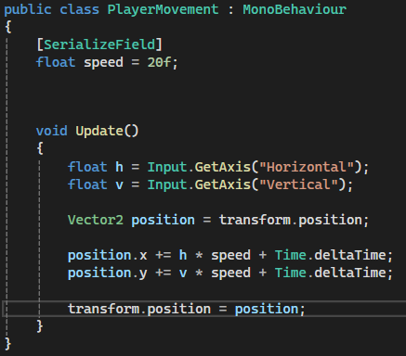

There was, however, an issue with the movement, as the player would constantly move in a north-east direction. On inspection of my code, however, I quickly found that this was just because I had added Time.deltaTime instead of multiplying by it.

Stage 1 Vid 1

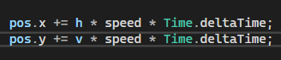

I changed this, and it worked pretty much as intended.

Stage1Vid2

There was one issue with the movement, however. Due to the calculations for moving horizontally and vertically being completely separate, if you move in both directions at the same time, due to the laws of Pythagoras, you are moving faster than usual by a factor of sqrt(2), which is an issue because it makes movement feel inconsistent. To solve this, I changed it so that instead of the calculations using the base ‘speed’ value, they would use individual ‘speedV’ and ‘speedH’ values. These will usually just equal the base speed, but if both a vertical and horizontal key is pressed, they will equal speed divided by sqrt(2). I could’ve removed the base speed entirely and just had everything calculated with these two variables, but if I want to change how fast the player moves, I think it will be easier to just change the base speed instead of both speed variables, especially because issues could be caused if I change one and forget to change the other. However, to perform this calculation in the code, I needed to have a way to take the square root of a number, which was something I didn’t know how to do. I was able to find out how after some short research of the Unity documentation though, and it worked perfectly.

(“Scripting API: Mathf.Sqrt”)

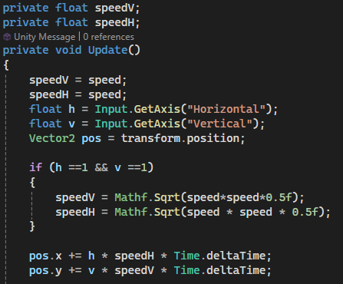

After this, I wanted to start on the shooting mechanics. For this to work, I would need the location of the mouse so that the hammers can calculate the direction they need to travel in. I also decided the best way to translate this to the player would be the Crosshair, otherwise the player wouldn’t be able to know precisely where the hammers will travel. I didn’t know how to get the position of the mouse, so I looked at the Unity documentation and found that you had to get the vector position of the mouse with Input.mousePosition. After this, I assumed it would be as simple as setting the position to this new vector, because that’s how it worked with player movement.

(“Unity - Scripting API: Input.mousePosition”)

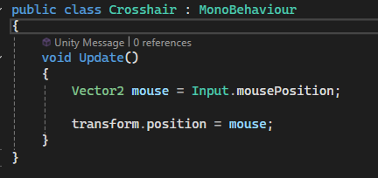

However, after testing it, there seemed to be an issue where the position of the mouse didn’t correlate with the game screen.

Stage1Vid3

I assumed the issue was something to do with the code using the mouse’s position on the UI instead of the camera, but I had no clue how to fix it, so I found a tutorial on making the player move with the mouse on YouTube. It turned out you needed to specify that it was using the camera position, as seen below. After that, it worked perfectly.

(Modding by Kaupenjoe)

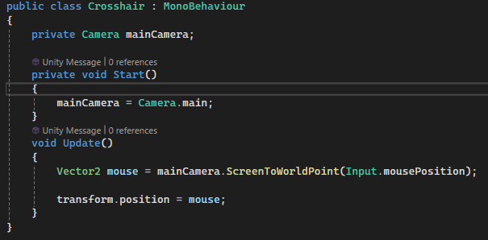

Stage1Vid4

I then started on creating the code for the hammer projectile. It needs a damage variable, which I want in the Hammer to simplify the future code for hitting enemies, a direction variable, so it knows what angle to fly at, and a speed variable, so it knows how fast to fly. I originally was going to have these all assigned through a constructor, which I thought would be best so that when the player calls the hammer, it could be called with these stats being different depending on the power-ups the player has, making it easier for me to do everything from the player class code. I then created the move() method, which takes in the direction and speed, the two variables that will affect movement. I then took some code from my PlayerMovement script, because this code will be very similar, so reusing it will save me time. I did have to alter it to include the trigonometric calculations for the rate that the x and y coordinates change, to make it fly towards the mouse. 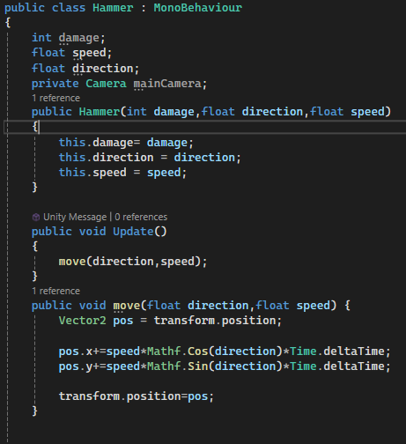

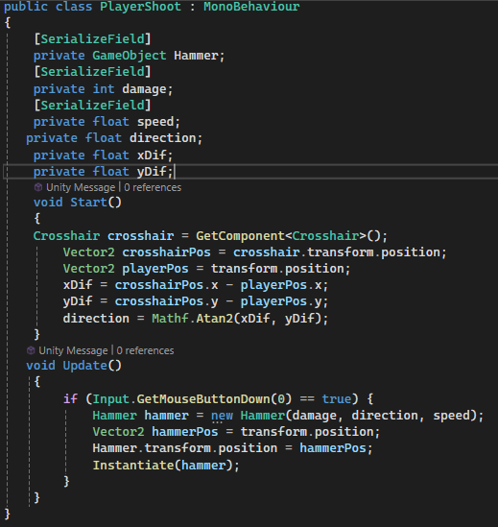

After I created the Hammer, I moved on to the PlayerShoot() method, which is important so that I can test the Hammer code. I thought it would be best to get the location of the crosshair, find the difference between that and the player positions, and then calculate the angle between the player and the crosshair. In Update(), it would check each frame if the mouse was clicked, and if it did it should initialise a Hammer with the correct parameters. I chose to use the crosshair to calculate the angle, as that is a better and larger visual indicator for the player than my other option, the mouse. I also put the check for the mouse getting clicked in the Update() method, so that it would be as responsive as possible, as Update() is called every frame.



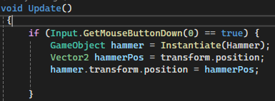

When I tried running it I received these errors. There seemed to be something wrong with using the ‘new’ key word, and also that something had the value of null. I thought the cause of the null error may have been that I instantiated the Hammer at the end, so I changed that, and to fix the error with using ‘new’, I just had to check back at my notes to see I was instantiating it like I would with regular C code, which doesn’t work for Unity. These changes got the Hammers to spawn, however they didn’t move.

Stage1Vid5

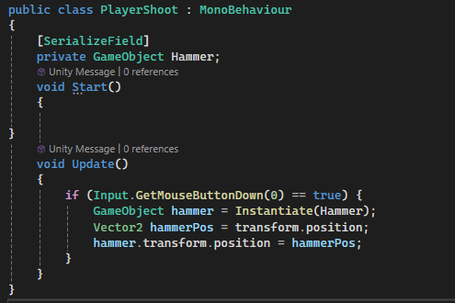

The first change I did was moving all calculations to the Hammer class. This is so I won’t have to rely on passing the Direction variable in, and also makes it easier to work on the Hammer code, as all things Hammer related are in the Hammer class. I also calculated the angle with the mouse position, as opposed to the crosshair. Whilst it may cause some disparity between what the player is seeing and how the projectile fires, the difference between the crosshair location and the mouse will be a few pixels at most, and this option is simpler to code, and more reliable overall.

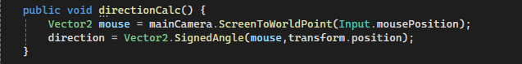

These changes got the Hammers to travel, but in seemingly random directions. It wasn’t fully random, though, as I noticed there was a periodic pattern, so I assumed the issue was that the Atan gave the angle in degrees, whereas sin and cos were using the angles though it was in radians.

Stage1Vid6



I added some code to change direction from degrees to radians, which was better, but seemed to be firing the Hammer in the complete opposite X direction than what it should.

Stage1Vid7



I reversed the X direction by multiplying Cos(direction) by -1. This was better, but still inconsistent. However after some testing, this seemed to be because the code was using (0,0) to calculate the angle instead of the Player’s position.

Stage1Vid8

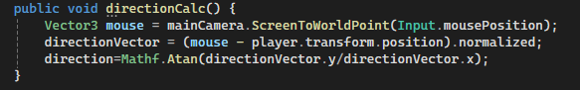

The issue was that the code was doing calculations with 2 Vectors that both stem from the origin, when I needed to do calculations with the vector connecting these 2 points. This was an easy enough fix, and after that it worked perfectly.

Stage1Vid9

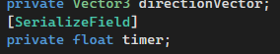

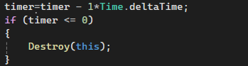

In the code's current state, the Hammers would travel infinitely and never get destroyed. If I kept it like this, this may cause performance issues after a lot of Hammers have been fired, as there would be a lot of calculations performed every frame, causing lag which may annoy the player. It may also cause balance issues, as the player may be able to sit in the corner of the map and hit anything with infinite range projectiles. Because of this, I wanted to add a way for the Hammers to be destroyed after a certain amount of time. I decided to do this by having a timer in the Update() method that decreased by 1 every second, and is destroyed when the timer hits 0. Alternatively, I could have it in a separate script, but to keep the Hammer easy to work on, I decided to combine it with the regular Hammer script.

Stage1Vid10

This code didn’t fully work. After the timer runs out, the Hammers freeze in place after the timer runs out. To try and diagnose the issue, I added ‘print(timer);’ after the timer changes value to check if it was an issue with that, but it wasn’t.

Stage1Vid11

I really didn’t know what the issue could be, so I tried looking at a discussion on the Unity website about someone with a similar issue. It turns out that Destroy(this) destroys the script of the gameObject, not the gameObject itself, meaning the Hammers would remain just without any code, so I changed it to Destroy(this.gameObject), which made it work fine.

(“Destroy(this) not working properly - Questions & Answers”)

Stage1Vid12

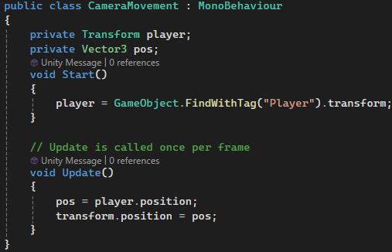

I then started working on making the camera follow the player - the final part of Stage 1 of development. I made a CameraMovement script that gets the player’s location, and transforms the Camera’s location to that spot. This was the most simple solution I could come up with, only using 5 lines of code. However, when I ran the program, you couldn’t see the player.

Stage1Vid13

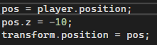

When looking at the Camera’s default position before it changed, it was at (0,0,-10). Setting the position to be equal to the player would make it be at (0,0,0), causing a change in the Z coordinate. I simply made it so that the Z coordinate would be set back to -10 after it changes, which worked perfectly. To demonstrate this I also added the beta design for the background, which hopefully reflects the dungeon setting I decided on from the stakeholders feedback.

Stage1Vid14

**Stage 2:**

Data Dictionary:

|  |  |  |  |  |
| --- | --- | --- | --- | --- |
| **Class** | **Attribute** | **Data Type** | **Method** | **Description** |
| **Enemy** | Health | Integer |  | Decreases when damaged, destroys object when =0 |
|  | Speed | Float |  | The speed the enemy moves at |
|  | Damage | Integer |  | Damage dealt to player if they get hit |
|  |  |  | Movement() | Method for moving in the direction of the player |
|  |  |  | Shooting() | (RANGED ONLY) shoots projectile at the player |
|  |  |  | Melee() | (MELEE ONLY) damages player if it touches them |
|  |  |  | Damaged(int damage) | If they collide with a hammer, they lose health, and get removed if health =0 |
| **EnemyProjectile** | Direction | Float |  | The angle the projectile moves at |
|  | Speed | Float |  | The speed the projectile moves at |
|  | DespawnTimer | Integer |  | Decreases every second, destroys projectile when =0 |
|  | Damage | Integer |  | How much damage the projectile does |
|  |  |  | Flying(float direction) | Method for projectile travelling |

Movement():

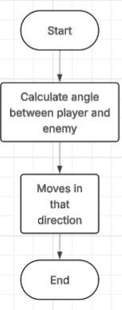

The movement will be very simple, with the enemy simply moving towards the player non-stop. To keep the enemy AI simple to understand for the enemy, all it does is move towards the player’s direction, worked out with simple trigonometric calculations, making it quick and easy to code for me, allowing me to focus on adding more, different to increase variety in the game.

Shooting():

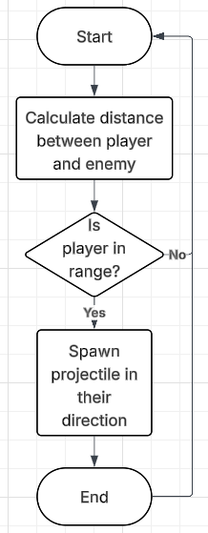

Shooting will be in the form of an IF statement in the Update() function that is always checking if the player is in range for the attack. I’m using an IF statement so that no other code has to run if the player isn’t in range. If they are in range, it will spawn a projectile which will share a lot of code with the Hammer, saving me time.

Melee():

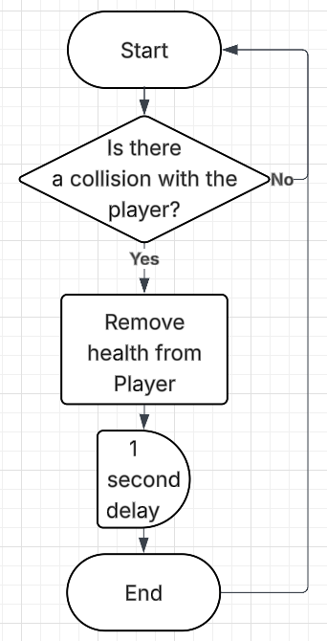

Melee attacks will have a repeating IF statement to constantly check if the player is touching a melee enemy. I want to do this so that the instant the player touches an enemy, they get damaged, increasing the difficulty and removing any buggy-looking interactions. I’m also adding a 1 second delay so that the player has some wiggle room and isn’t damaged every single frame, as that would make the game feel impossible and kill the player almost instantly. The delay should be after the player takes damage, or else the game will feel unresponsive which may irritate the player.

Damaged(int damage)

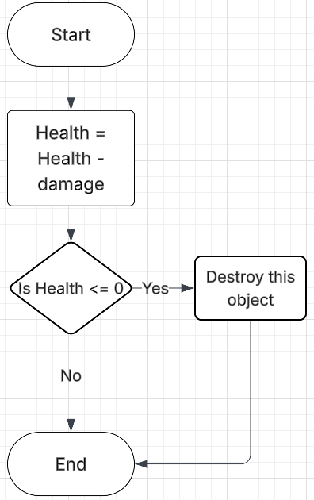

Damage will be very simple, just removing the health when called, with the damage passed in as an integer variable. I’m using integers for health and damage for the sake of it being easier to understand for the player, as there will be less digits than in a float. It then checks if the enemy has 0 health or less - meaning it’s dead - and removes it if it is. I put this IF statement in the damaged() method because they both are to do with health, and it saves storage space because I don’t have to code an entirely different method.

Flying()

Uses reusable components from the Hammer’s movement code, but replacing the crosshair with the player.

**Stage 2 Development:**

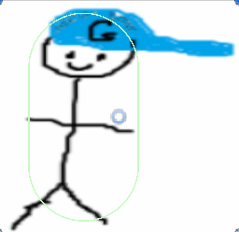

Added collider to player and hammer

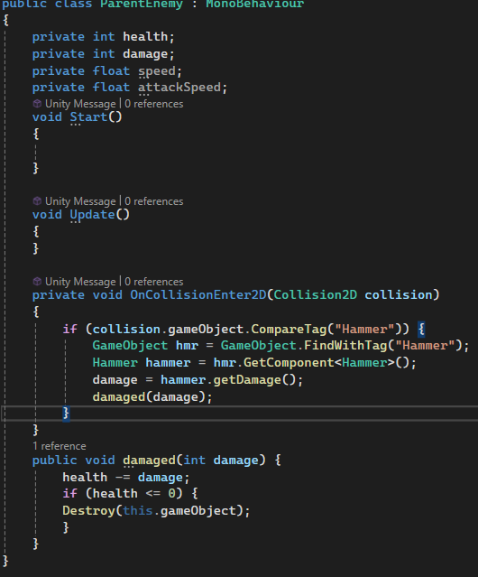

Made parent enemy class along with damaged() method

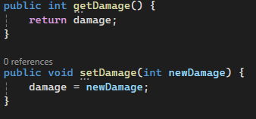

Added get and set damage in Hammer code

Started to try and test the damaged() code

Stage1Vid1

Added print(“1”) and print(“2”)

Stage2Vid2

Unchecked isTrigger, and changed to hmr=collision.gameObject bc otherwise it could use any hammer

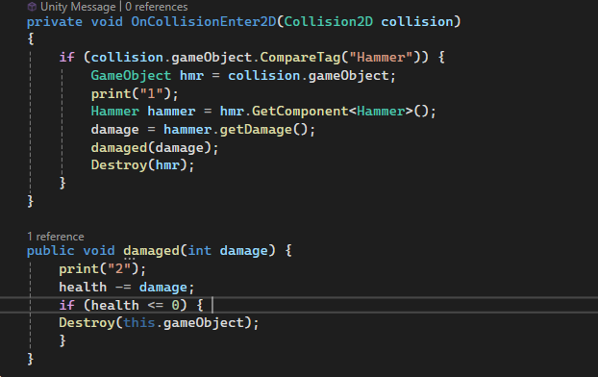

Stage2Vid3

Decided against using a parent class and inheritance because, outside of taking damage, melee and ranged enemies will operate very differently and it will be easier to set the different variables using [SerializedField] for testing purposes.

Started on movement. Was able to reuse a lot of components from the Hammer code.

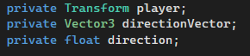

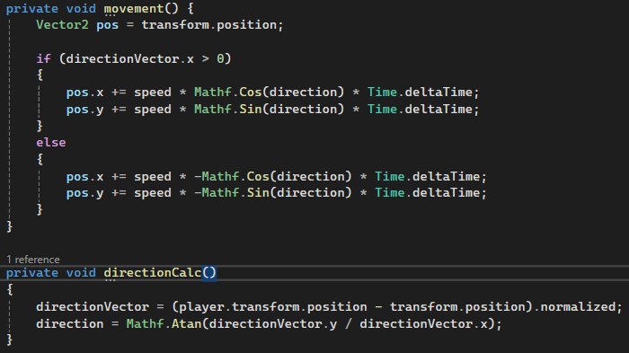

Wasn’t moving.

Stage2Vid4

Added print(1) when it calculates direction, print(2) when update runs, and print(3) when changing the position vector. It printed all of these showing it should work fine.

Stage2Vid5

This made me realise I never set the transform to pos. Changed that.

Stage2Vid6

Only travelled in 1 direction. This is because I only calculate direction once. Changed that.

Stage2Vid7

Worked until the enemy and player were on the same space. This is because there will be some dividing by 0.

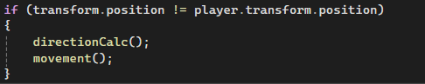

Worked

Stage2Vid8

Started on the dash

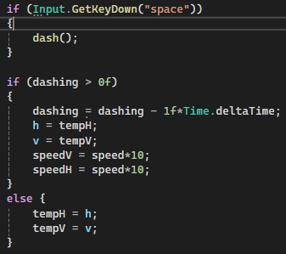

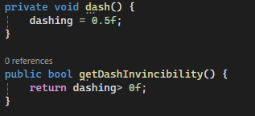

Worked basically perfectly, just maybe a bit too fast and last too long

Stage2Vid9

Changed the values

Stage2Vid10

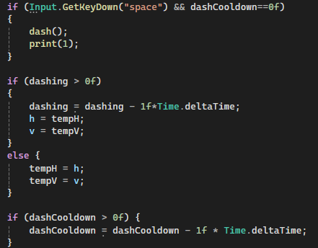  
Added cooldown to dash. Tried but it made you only dash once (I’m spamming space in the video)

Stage2Vid11

Remembered -Time.deltaTime isn’t minusing integers, so changed it to <=0 and it worked.

Stage2Vid12

https://docs.unity3d.com/6000.2/Documentation/ScriptReference/SpriteRenderer.html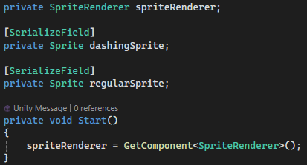

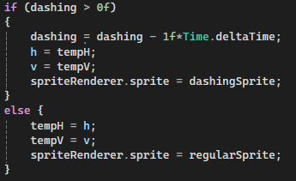

Worked fine. Sprite size needs reformatting but that can be in aesthetics 1 stage.

Stage2Vid13

Citations: